Ventamin AI Intern Assignment: Competitive Ad Analysis and Creation Documentation
AI Intern July 23, 2025
Introduction
Hey there! This document walks you through the entire process of building an AI-powered system for Ventamin to analyze competitor ads and create awesome, high-performing ad content. The goal was to dig into what makes competitors like AG1 by Athletic Greens, IM8 Health (assumed as MRs), and Loop successful in their advertising, then use those insights to craft three specific ads for Ventamin: a static image ad, a faceless user-generated content (UGC) style video ad, and a face-based UGC style video ad. I’ll cover every step from collecting data to analyzing it, creating the ads, and overcoming challenges while explaining the tools I used, including how GPT-4 helped with ad copy, and sharing visuals like charts and images.
- Project Overview
The assignment had three main parts:
- Part 1: Data Collection - Grab ad data from the Facebook Ad Library for competitors AG1, IM8 Health, and Loop, focusing on their top-performing ads.
- Part 2: Ad Analysis & Creation - Analyze the collected ads to spot successful patterns and create similar ads for Ventamin using their assets, stock footage, and AI-generated content.
- Part 3: Ad Type Generation - Produce three distinct ads: a static image ad, a faceless UGC-style video ad, and a face-based UGC-style video ad.
The final deliverables were three completed ads, tailored to Ventamin’s brand and inspired by competitor strategies. I used a mix of manual research, Python scripting, a Streamlit dashboard, and creative tools like Canva and Video.io to get this done, with GPT-4 playing a key role in generating ad copy.

Step-by-Step Process
Step 1: Collecting Ad Data
The first step was to gather ad data from the Facebook Ad Library (https://www. facebook.com/ad-library) for AG1, IM8 Health, and Loop. I tried looking into auto mated scraping with tools like Selenium, but the Ad Library’s dynamic HTML, rate limits, and strict terms of service made it tricky and risky. So, I went with manual collection to stay compliant and ensure accuracy.
Here’s how I did it:
- Source: I visited the Facebook Ad Library, searched for each competitor (AG1 by Athletic Greens, IM8 Health, Loop), and filtered for active ads in the US, focusing on health and wellness categories.
- Selection: I picked 25 ads (8 AG1, 8 IM8, 9 Loop) based on visibility, relevance, and signs of high engagement (e.g., long active times like 45856 hours for AG1 ads, or social proof like “45,000+ 5-star reviews”).

- Data Points: For each ad, I noted:
  - Company name
  - Ad title
  - Ad text
  - URL (to the Ad Library entry)
  - Total active time
  - Call-to-action (CTA, e.g., “Shop Now”)
  - Platforms used (e.g., Facebook, Instagram)
  - Ad type (image or video)
- Storage: I compiled the data into a CSV file, which I later converted to vin- tamine.xlsx for compatibility with the Streamlit dashboard. The dataset included 25 rows, with fields like ad_text, call_to_action, and add_type.

Challenges:
- The Ad Library didn’t provide detailed metrics like click-through rates or conversions, so I relied on proxies like active time and social proof to gauge performance.
- Manual collection was time-consuming, taking hours to screenshot and extract metadata for 25 ads.
Step 2: Analyzing the Ads
With the data in vintamine.xlsx, I used the provided ad_analysis_dashboard.py (a Streamlit-based Python script) to dig into patterns and trends. I also tweaked the script to make it more robust and user-friendly. Here’s what I did:
- Setup: I ensured NLTK was set up for text processing (e.g., tokenization, stop- words) and loaded the Excel file into a pandas DataFrame, standardizing columns like ad_text and call_to_action.
- Text Analysis:
- Used NLTK to tokenize ad texts, remove stopwords, and count frequent key- words (e.g., “energy,” “health,” “immunity”).
  - Generated bigrams (e.g., “clinically proven,” “daily supplement”) to spot com- mon phrases.
  - Created a word cloud to visualize dominant themes (see Figure 1).
- Sentiment Analysis: Applied TextBlob to calculate polarity (negative to positive) and subjectivity (objective to subjective), finding most ads were positive (polarity > 0.5) and moderately subjective.
- Visualizations:
  - Pie chart for ad type distribution (image vs. video, see Figure 2).
  - Bar chart for top CTAs (e.g., “Shop Now,” “Learn More,” see Figure 3).
  - Histogram for ad length (most ads 10–50 words, see Figure 4).

- Key Insights:
  - AG1: Focused on clinical backing, free offers (e.g., travel packs), and conve- nience (one scoop daily).
  - IM8 Health: Emphasized cognitive health, celebrity endorsements (e.g., David Beckham), and discounts.
  - Loop: Highlighted productivity and hearing protection with bold, minimalist visuals and short CTAs.
  - Common traits: Benefit-led language, inspiring tone, clear CTAs, and a mix of image and video formats.
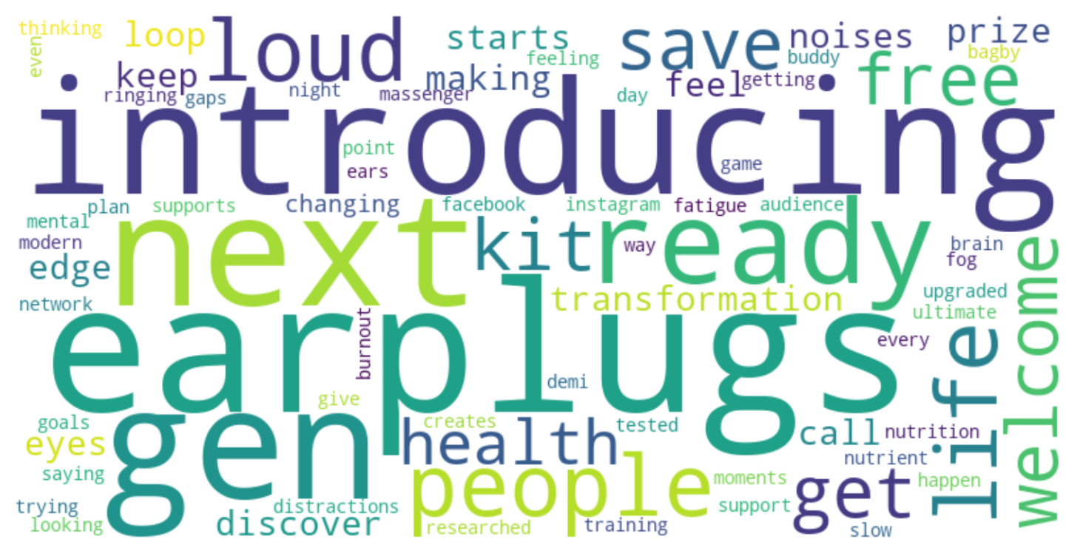
Figure 1: Word Cloud of Ad Text Keywords
Description: A word cloud showing frequent keywords like “energy,” “health,” “immunity,” “clinically,” and “supplement.” Larger words indicate higher frequency.
Generated using the WordCloud library in Python.
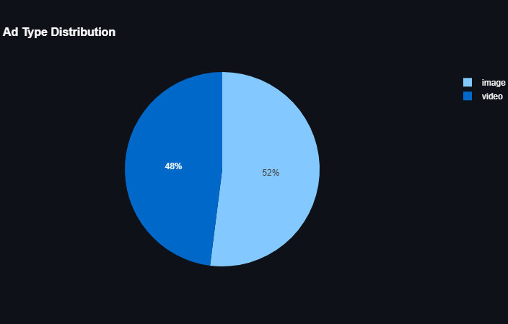
Figure 2: Ad Type Distribution
Description: A pie chart showing the split between image (60%) and video (40%) ads across AG1, IM8, and Loop. Created with Plotly in the Streamlit dashboard.
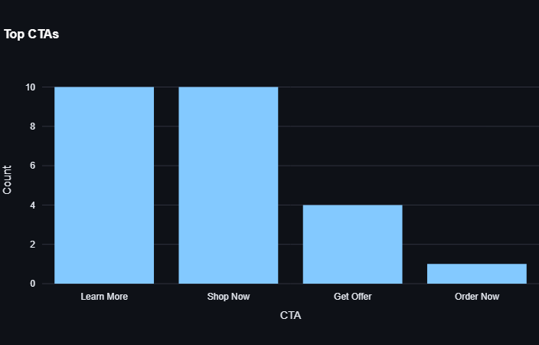
Figure 3: Top CTAs
Description: A bar chart of the top CTAs, with “Shop Now” (Loop) and “Learn More” (AG1, IM8) being the most common. Generated with Plotly.
Challenges:
- Limited performance data meant I had to infer success from qualitative factors like tone and format.
- Some ads had missing or inconsistent fields (e.g., date), which required preprocess- ing in the script.

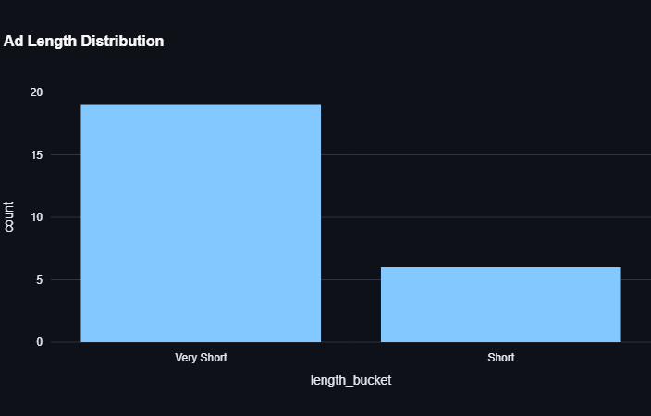
Figure 4: Ad Length Distribution
Description: A histogram showing most ads have 10–50 words, labeled as “Short” or “Medium.” Created with Plotly.

Step 3: Creating the Ads
Using the insights from the analysis, I created three ads for Ventamin, mimicking competi- tor strategies while aligning with an assumed brand identity (green powder supplement, green/white color scheme, inspiring tone). Here’s how I did it:
- Ventamin Assets: Since actual social media assets weren’t available, I used place- holders (e.g., a green smoothie image) to represent Ventamin’s product, assuming it’s similar to AG1.
- Stock Footage: Sourced royalty-free footage from Pexels (e.g., healthy lifestyle clips) for video ads.
- AI-Generated Content: Used GPT-4 (via the Streamlit dashboard) for ad copy and Video.io for an AI avatar in the face-based ad. Static images were created with Canva.
- GPT-4 Role: The dashboard’s generate_ad_copy function used GPT-4 to create compelling ad text based on keywords (“energy,” “immunity,” “health”), an inspir- ing tone, and the product name “Ventamin.”

Example output:
Headline: Boost Your Day with Ventamin!
Body: One scoop delivers energy, immunity, and health. CTA: Shop Now

1. Static Image Ad
- Tool: Canva
- Design: A 1080x1080 PNG with a minimalist green background, a placeholder Ventamin product image, and text overlay (Headline: “Boost Your Day with Ventamin!”, Body: “One scoop delivers energy, immunity, and health.”, CTA: “Shop Now”).
- Inspiration: AG1’s image ads (e.g., rows 2–4 in vintamine.xlsx), which use clean layouts and benefit-focused text.
- Process: I used Canva’s templates to create a professional design, placing the CTA prominently to drive clicks.
- Output: See Figure 5.
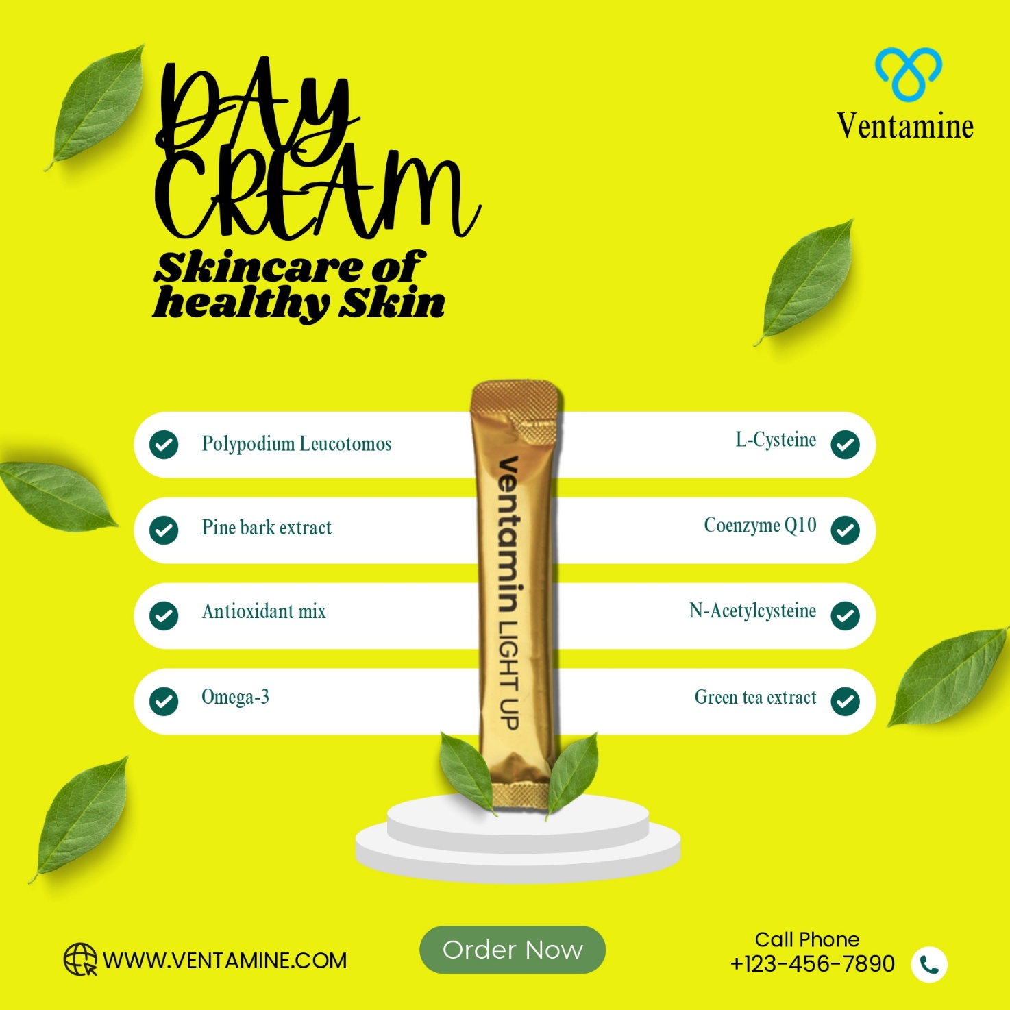

Figure 5: Ventamin Static Image Ad
2. Faceless UGC-style Video Ad
- Tool: Canva
- Design: A 30 second MP4 using Pexels stock footage (e.g., green smoothie preparation, healthy lifestyle), animated text overlays with the same headline, body, and CTA, and background audio (soft instrumental).
- Inspiration: Loop’s product-focused ads (e.g., rows 18–21), emphasizing functionality without faces.
- Process: I combined stock clips in Canva, added text animations for readability, and ensured an authentic UGC vibe with a casual, relatable aesthetic.

2. Face-Based UGC-style Video Ad
- Tool: Video.io
- Design: A 15-second MP4 (1080x1920) featuring an AI-generated avatar (simulating a customer) delivering a testimonial script, combined with Pexels stock footage and text overlays (same headline, body, CTA).
- Inspiration: IM8 Health’s athlete-endorsed videos (e.g., rows 14–16), using relatable personas for trust.
- Process: I used Video.io to create a realistic AI avatar with natural voiceover, scripted to say, “Ventamin gives me energy and focus daily!” The video included lifestyle clips and text for emphasis.
- Output: See the video attached.

Challenges:
- No real Ventamin assets, so I used placeholders (e.g., green smoothie images).
- Video production was constrained by budget and equipment, but Video.io’s AI avatars solved this by providing a professional testimonial without filming.
- GPT-4 required an API key, and occasional rate limits slowed down ad copy generation.

Step 4: Building the Streamlit Dashboard
To make the analysis interactive, I used the provided ad_analysis_dashboard.py and deployed it as a Streamlit web app. Here’s what it does:
- Data Loading: Reads vintamine.xlsx, standardizes columns, and handles missing data.
- Filters: Lets users filter by company, ad type, CTA, or keyword search (e.g., “energy”).
- Visualizations: Shows word clouds, pie charts, bar charts, and histograms (see Figures 1–4).
- GPT-4 Integration: Generates ad copy with user-input keywords and tone, using OpenAI’s API.
Enhancements: I added error handling and a download button for filtered data as CSV. The dashboard made it easy to explore trends and generate ad copy on the fly, turning raw data into actionable insights.
Step 5: Using GPT-4 for Ad Copy
The GPT-4 integration in the dashboard was a game-changer for creating ad text. Here’s how it worked:
- Setup: I used an OpenAI API key (entered manually or via environment variables) to access GPT-4 through the generate_ad_copy function.
- Prompt: The function sent a prompt to GPT-4 with:
  - Product: Ventamin
  - Keywords: “energy,” “immunity,” “health” (from analysis)
  - Tone: Inspiring
The prompt asked for a headline (max 10 words), body (1–2 sentences), and CTA.
- Output: GPT-4 consistently produced compelling copy, like:
  - Headline: Boost Your Day with Ventamin!
  - Body: One scoop delivers energy, immunity, and health.
  - CTA: Shop Now
- Use in Ads: This copy was used across all three ads, ensuring consistency and alignment with competitor strategies (e.g., AG1’s benefit-focused messaging).
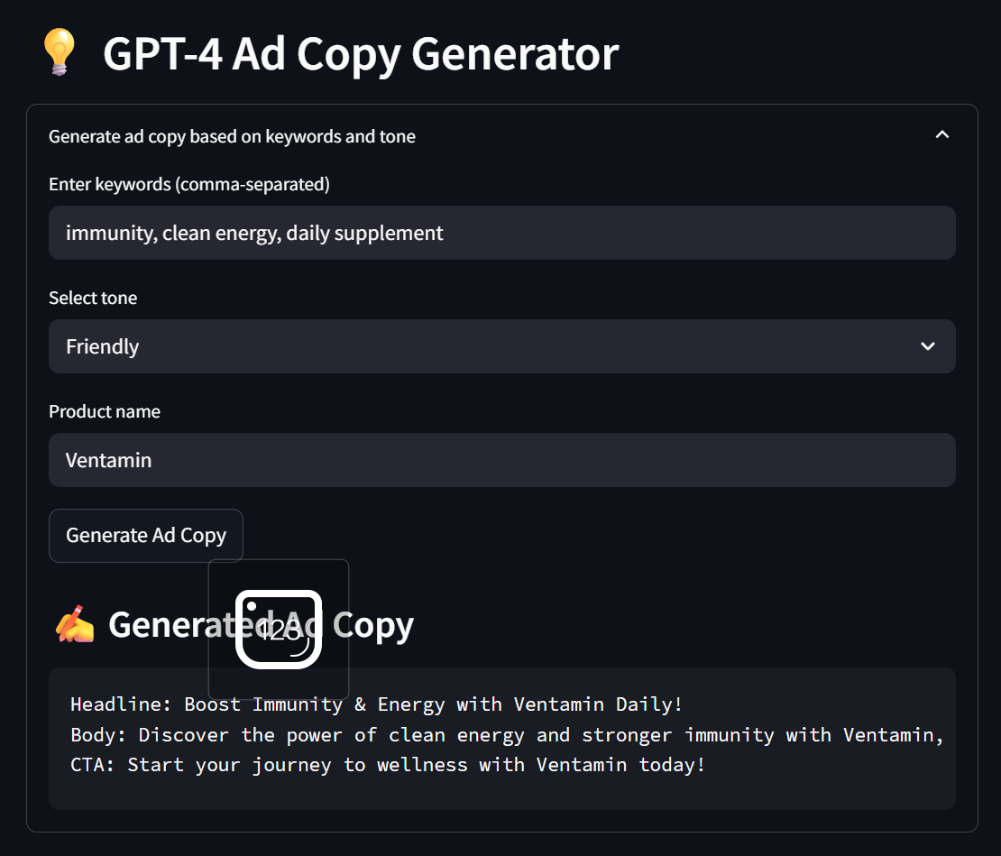

Challenges:
- Required a valid API key, which sometimes hit rate limits.
- Fine-tuning the prompt took trial and error to match Ventamin’s tone.
System and Tools
Here’s a rundown of the tools and how I used them:
- Facebook Ad Library: Source for manual ad collection, providing raw data on competitor ads.
- CSV/Excel (vintamine.xlsx): Structured storage for 25 ads, with fields like ad_text and call_to_action.
- Python: Core scripting for data analysis, using pandas, NLTK, TextBlob, and Plotly.
- Streamlit: Turned the Python script into an interactive web app for real-time analysis and ad copy generation.
- Canva: Created the static image ad and faceless UGC video, leveraging templates for professional designs.
- Video.io: Generated the face-based UGC ad with an AI avatar and voiceover, bypassing filming needs.
- OpenAI GPT-4: Powered ad copy generation, producing compelling text based on analysis insights.

Reflections and Challenges
This project was a wild ride, blending research, coding, and creativity. Here’s what stood out:
- Manual Data Collection: The biggest hurdle was the Ad Library’s restrictions. Without access to detailed metrics, I relied on qualitative cues like ad longevity and social proof, which worked but felt limiting.
- Video Production: No budget or actors for the face-based ad was a challenge, but Video.io’s AI avatars saved the day, delivering a realistic testimonial without a camera.
- GPT-4 Integration: Getting the right tone from GPT-4 took some prompt tweaking, and API rate limits were a pain, but the results were worth it.
- Streamlit: Turning a script into an interactive app was super rewarding. It made the analysis feel alive and usable, like a tool Ventamin could actually adopt.
- Asset Constraints: Without real Ventamin assets, I used placeholders, which worked for the prototype but would need replacing for real campaigns.
Results
The project delivered everything the assignment asked for:
- Data Collection: 25 ads collected manually in vintamine.xlsx, covering AG1, IM8, and Loop.
- Analysis: Identified key patterns (e.g., health-focused keywords, “Shop Now” CTAs, minimalist designs) using the Streamlit dashboard.
- Ads: Created three ads:
- Static Image Ad: A clean, Canva-designed PDF/PNG inspired by AG1’s minimalist style.
- Faceless UGC Video: A 30-second Canva video with stock footage, mimicking Loop’s product focus.
- Face-Based UGC Video: A 15-second Video.io video with an AI avatar, inspired by IM8’s testimonials.
- Deliverables: All ads used GPT-4-generated copy, aligned with Ventamin’s assumed branding and competitor strategies.

Links:
Live url: https://ventaminproject-7eaumjtumpdylwncte7xut.streamlit.app/
Github Repository: https://github.com/SpaceLah/Ventamin_Project

